Name: Veeransh Shah

Reg No: 221070063

Experiment No: 10

Aim: Create a graph and check whether the created graph has a cycle or not.

Theory: To find cycle in a directed graph we can use the [Depth First Traversal](https://www.geeksforgeeks.org/depth-first-search-or-dfs-for-a-graph/) (DFS) technique. It is based on the idea that there is a cycle in a graph **only if there is a back edge** [i.e., a node points to one of its ancestors] present in the graph.

To detect a back edge, we need to keep track of the nodes visited till now and the nodes that are in the current recursion stack [i.e., the current path that we are visiting]. If during recursion, we reach a node that is already in the recursion stack, there is a cycle present in the graph.

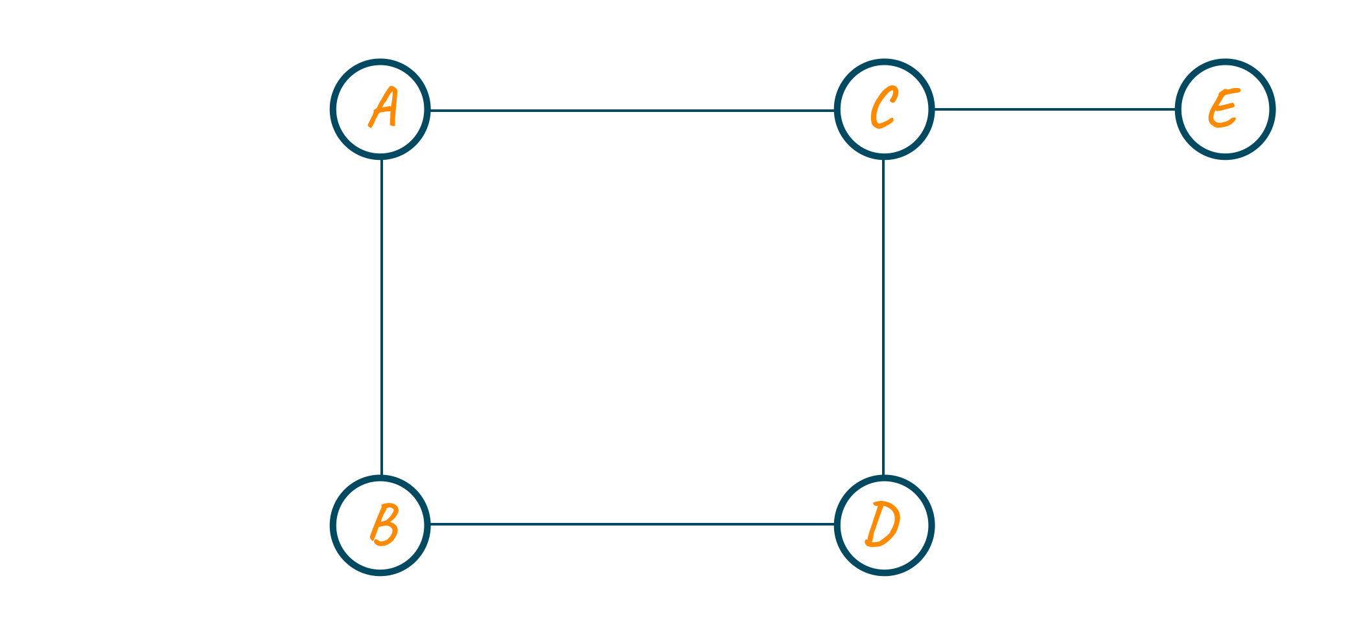

* Nodes: The graph consists of 5 nodes labelled A, B, C, D, and E. Nodes are represented as blue circles.
* Edges: The edges, represented as black lines, connect the nodes in the following way:
  + A is connected to B and C
  + B is connected to D
  + C is connected to D and E
  + E is connected to D
* Cycle: The graph has a cycle. This means that it is possible to start at one node and traverse the graph in such a way that you end up back at the starting node without revisiting any node. In this case, you could start at node A, move to B, then D, then E, and finally back to A to form a cycle.

Algorithm:

Detect Cycle in Undirected Graph using DFS

Input:

* n: Number of nodes in the graph
* e: Number of edges in the graph
* Edges between nodes (u, v)

Output:

* Determine whether the graph contains a cycle or not.

Function Definitions:

1. createList(vector<int> adjList[], int e):
   * Initialize an adjacency list to represent the graph.
   * For each edge, add an entry in the adjacency list for both vertices.
2. display(vector<int> adj[], int n):
   * Display the adjacency list to visualize the graph.
3. isCycleUtil(vector<int> adj[], int v, vector<bool> &visited, int parent):
   * Perform a DFS traversal on the graph.
   * Mark the current node as visited.
   * For each adjacent node:
     + If the adjacent node is not visited, recursively call isCycleUtil.
     + If the adjacent node is visited and is not the parent of the current node, a cycle is detected.
   * If no cycle is found, return false.
4. isCycle(vector<int> adj[], int n):
   * Initialize a boolean array visited to keep track of visited nodes.
   * Iterate through all nodes in the graph.
   * If a node is not visited, call isCycleUtil starting from that node.
   * If isCycleUtil returns true for any component, there is a cycle in the graph.

Main Function:

1. Input:
   * Accept the number of nodes (n) and edges (e).
   * Create an adjacency list (adjList) to represent the graph.
2. Detect Cycle:
   * Call the isCycle function with the adjacency list and the number of nodes.
   * If a cycle is detected, print "Cycle exists in the graph."
   * If no cycle is detected, print "No cycle in the graph."

Time Complexity:

The time complexity of this algorithm is O(V + E), where V is the number of vertices (nodes) and E is the number of edges in the graph. This is because each vertex and each edge is visited once during the DFS traversal.

Space Complexity:

The space complexity is O(V), where V is the number of vertices. This is due to the space required for the adjacency list and the boolean array to track visited nodes.

Code:

#include <iostream>

#include <vector>

using namespace std;

void createList(vector<int> adjList[], int e)

{

cout << "Enter the edges between the nodes: " << endl;

for (int i = 1; i <= e; i++)

{

int u, v;

cin >> u >> v;

adjList[v].push_back(u);

adjList[u].push_back(v);

}

}

void display(vector<int> adj[], int n)

{

for (int i = 1; i <= n; i++)

{

cout << i << "_>";

for (auto x : adj[i])

{

cout << x << " ";

}

cout << endl;

}

}

bool isCycleUtil(vector<int> adj[], int v, vector<bool> &visited, int parent)

{

visited[v] = true;

for (auto i : adj[v])

{

if (!visited[i])

{

if (isCycleUtil(adj, i, visited, v))

return true;

}

else if (i != parent)

{

return true;

}

}

return false;

}

bool isCycle(vector<int> adj[], int n)

{

vector<bool> visited(n + 1, false);

for (int i = 1; i <= n; i++)

{

if (!visited[i])

{

if (isCycleUtil(adj, i, visited, -1))

return true;

}

}

return false;

}

int main()

{

int n, e;

cout << "Enter the number of nodes and edges: ";

cin >> n >> e;

vector<int> adjList[n + 1];

createList(adjList, e);

display(adjList, n);

if (isCycle(adjList, n))

{

cout << "Cycle exists in the graph" << endl;

}

else

{

cout << "No cycle in the graph" << endl;

}

return 0;

}

Example:

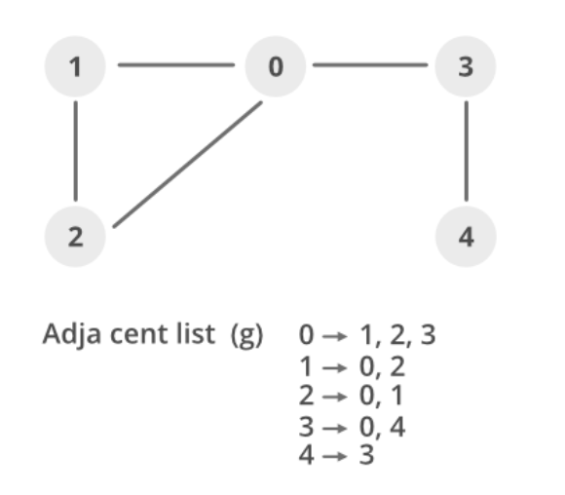

1. Recursion Stack and Visited Array: Let’s consider the graph created in the main function with edges (0-1), (0-2), (0-3), (1-2), and (3-4). Here’s how the recursion stack and visited array change as the DFS progresses:
   * Start DFS at vertex 0: Recursion Stack = [0], Visited = [true, false, false, false, false]

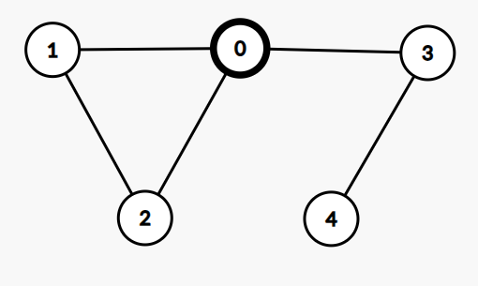

* + Visit vertex 1 from vertex 0: Recursion Stack = [0, 1], Visited = [true, true, false, false, false]

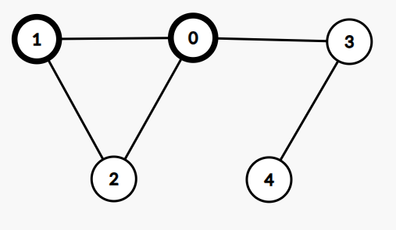

As 0 is already visited and is a parent of 1 no cycle is found.

* + Visit vertex 2 from vertex 1: Recursion Stack = [0, 1, 2], Visited = [true, true, true, false, false]

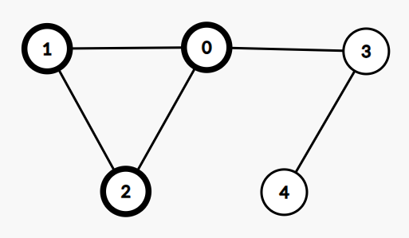

As 1 is already visited and is a parent of 2 no cycle is found.

Vertex 2 has an adjacent vertex 0, but 0 not the parent of 2 in the DFS tree, a cycle is detected. So we return from the recursive calls.

Conclusion:

We can successfully detect cycles in an undirected graph using DFS in linear time complexity of O(V + E), where V is the number of vertices and E is the number of edges in the graph. The code also uses a simple data structure of linked lists to represent the graph as an adjacency list. The code can be tested with different graphs by changing the number of vertices, the edges, and the starting vertex in the main function.